Leveraging Data Science Techniques for Building a Customer Service Chatbot: A Study on Design and Development

Project Proposal

Nyein Than Thar (21071926)

2023

## Introduction

The recent decade has witnessed a rapid-growth of online services along with a significant boom in Technology. Over the years, technology has become more user-friendly and accessible. The increase in accessibility has resulted in a dramatic increase in a number of users. Therefore, it has been a challenge for businesses to provide customer support to each and every customer.

During the Covid-19 pandemic period, the use of chatbot gained more popularity. More than 30,000 chatbots have been launched in the US market on messaging platforms such as Facebook Messenger and Viber, with approximately two billion messages sent per month on these platforms (Jansom et al., 2022).

The major benefits of using chatbot is the automation of mundane task, such as providing answers to repetitive questions for varieties of customers (Rakhra et al., 2021).

## Problem Statement

E-commerce has revolutionized the way we shop and billions of people are purchasing their essentials through various e-commerce platforms and it is expected to rise further in the future. As a result, problems related to their orders or payments arose, making it difficult to obtain to get an answer to their questions (Mamatha & Sudha, 2021). The increase in the use of e-commerce platforms has resulted in a dramatic growth in a number of queries. With this, Chatbots have become increasingly popular as a way to provide 24/7 customer support.

Customer service is crucial to an organization's ability to generate income and revenue. Traditionally, customer service staffs are employed to answers questions via telephone or messaging applications to deliver a greater customer satisfaction. However, there are two main issues associated with this approach: First, employee usually receive repetitive queries from a wide range of customers, which chatbots can be deployed to answer in a much more cost-effective way. Secondly, supporting 24/7 services is challenging, especially for most nonglobal businesses. For that reason, chatbots can be an excellent way to supplement customer service support because it is more economical and indestructible, freeing up support employee to answer much higher-value queries. (Cui et al., 2017)

To maintain the customer service and loyalty, e-commerce businesses must provide high-quality customer service. Chatbots have emerged as a promising solution for providing automated customer service; however, many existing chatbots continue to struggle to provide a satisfactory user experience.

## Aims and Scope

In this research, I propose to develop an AI-powered chatbot for e-commerce customer support chatbot which can improve customer satisfaction and reduce the workload of customer support agents. By automating the process of providing customer assistance, this AI-powered Chatbot aims to streamline the process. Users can approach to the chatbot for assistance and get answers to their questions instead on waiting for a representative to resolve their queries.

Additionally, this project is aimed to provide a user-friendly design solution to enhance usability and accessibly of the system. Specifically, this research will focus on developing conversational chatbot system which take into a large dataset of conversation history to provide the possible best answer for the customer’s query.

The following are the areas that will be focused for this project.

1. Literature Review
2. Data collection and preprocessing
3. Chatbot Implementation
4. Performance evaluation
5. User testing
6. Conclusion

The scope of this project is to focus on the development and evaluation of a customer service chatbot for an e-commerce. This include identifying of the datasets for the research and the target audience of the chatbot. To allow for a more focused analysis, the study could be limited to a specific industry, which is e-commerce.

Conversational agent or chatbot incorporate machine learning and natural language processing techniques to improve their accuracy and responsiveness (Hill et al., 2015).

**NLP** is regarded as a critical component of chatbots, processing raw data, munging it, cleaning it, and then preparing to take appropriate actions. We must write algorithms and employ NLP techniques to understand the user's natural language in whatever language it may be or whatever input form it may be (text, voice, image, etc.) (Raj, 2019).

Machine learning algorithm can be used to extract information and generate responses, and they can learn from previous conversations (Xufei & ASCS , 2021).

Chatbot's abilities can be gradually improve by training it on large datasets of customer interactions, making it appear more human and allowing it to better accommodate user needs (IBM Watson Advertising, 2022).

The results of this research aim to contribute to the development of more advanced and effective customer support chatbots which streamline the process of providing customer assistance for e-commerce related queries, improving their overall experience and satisfaction.

## Objectives

1. To conduct a comprehensive literature review of the existing literature on conversational chatbot development and e-commerce customer service.
2. To gather and preprocess a dataset of customer queries and responses in preparation for training the chatbot.
3. To implement a conversational chatbot using natural language processing (NLP) and machine learning algorithms. Train the chatbot on the preprocessed dataset and fine-tune the model using techniques such as transfer learning.
4. To evaluate the chatbot's performance using metrics such as accuracy, precision, recall, and F1 score (Fauzia et al., 2021)
5. User Testing
   1. To Conduct user testing to evaluate the user experience of the chatbot and identify areas for improvement.
   2. To conduct user survey to ask about their experience using the chatbot, their satisfaction with the chatbot's responses, and their likelihood of using the chatbot again in the future.
6. To provide recommendations for future study on conversational chatbots for e-commerce customer service and to present an overview of the project's main findings, potential limitations, and recommendations.

## Expected Outcomes

The expected outcomes of the projects could include the following:

1. Chatbot Application: a web application which could respond to the user questions in a timely and correct manner, enhancing the entire customer experience.
2. User experience research: This project could conduct user experience research on chatbot to determine user preference, expectations and any challenges in interacting with chatbot.
3. Increased efficiency and cost savings: This dissertation aims to demonstrate that the use of customer service chatbot can lead to enhance productivity and cost savings for business by eliminating the need of human customer service agents.

**Limitations**

1. The developed chatbot is unable to handle emotions as it is not designed to have emotional intelligence and cannot empathize with customers.
2. It may be incapable of dealing with multiple languages, limiting their effectiveness in serving customers who speak different languages.
3. Chatbot cannot make decisions.

By acknowledging these limitations, one can design and develop a more effective customer assistant chatbot for e-commerce that takes into account these potential issues and works to address them for the future research.

## Testing and Evaluation

According to Banchs & Li (2012), unit testing will be performed to ensure that individual component of a chatbot application, which include testing of NLP engine, conversation flow and any other key components. The model and chatbot’s functionality will be tested using a Likert scale (Fauzia et al., 2021).

Functionality testing will be conducted to test the chatbot’s ability to provide the relevant response for user queries as well as the overall user experience (Bhawiyuga et al., 2017). Questionnaires will be prepared to quantitative data about whether the usability goals and user experience have been met. A 5-point Likert scale will be used to create the questionnaire (Bhawiyuga et al., 2017).

## Ethical Considerations

The dataset which will be used in this dissertation is licensed under the Community Data License Agreement and data can be used to evaluate NLP platforms and intent recognition models (Bitext Innovations, 2020).

When conducting user feedback survey, key ethical considerations criteria such as ensuring informed consent, anonymity and confidentiality, voluntary participation, privacy, proper data use and dissemination, and fairness will be enforced. The preparation of questionnaire will be discussed further with supervisor.

## Project Plan

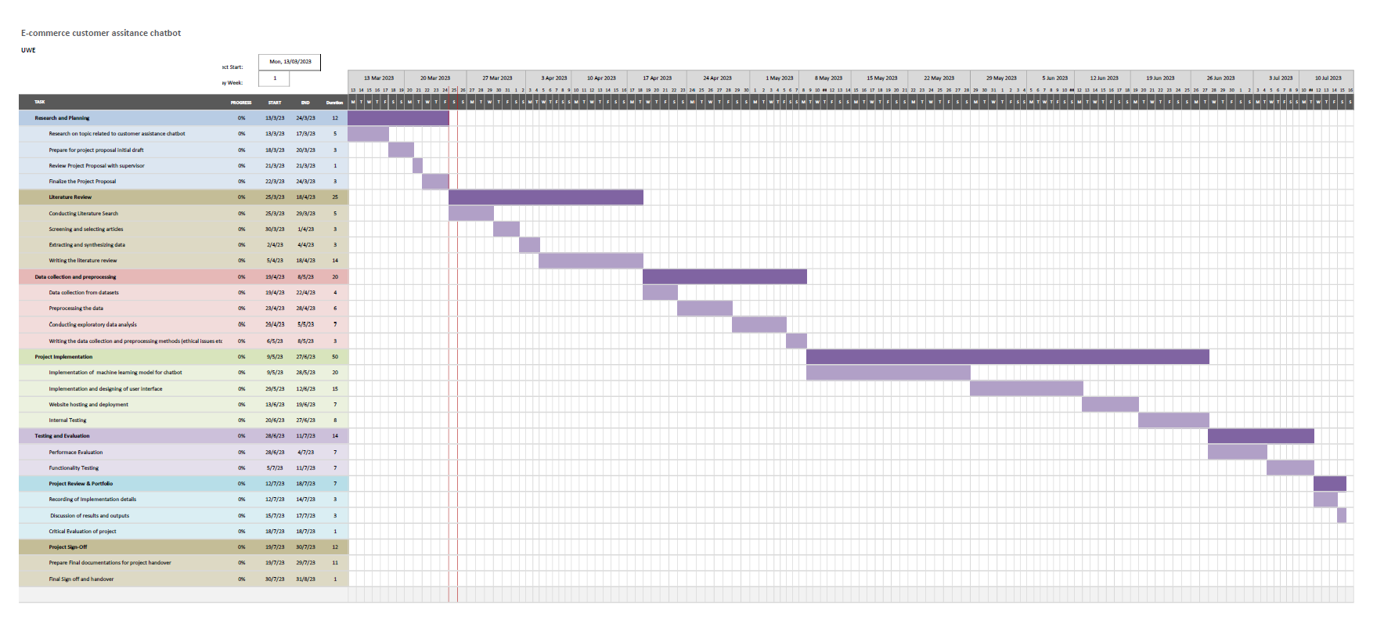

## Literature Review

1. Jansom, A., Srisangkhajorn, T. and Limarunothai, W. (2022) “How chatbot E-services motivate communication credibility and lead to customer satisfaction: The perspective of Thai consumers in the apparel retailing context,” Innovative Marketing, 18(3), pp. 15–27. Available at: https://doi.org/10.21511/im.18(3).2022.02. [Accessed 14 March 2023]
2. Hill, J., Randolph Ford, W. and Farreras, I.G. (2015) “Real conversations with artificial intelligence: A comparison between human–human online conversations and human–chatbot conversations,” *Computers in Human Behavior*, 49, pp. 245–250. Available at: https://doi.org/10.1016/j.chb.2015.02.026. [Accessed 14 March 2023]
3. Mamatha, M. and Sudha, C. (2021) “Chatbot for E-Commerce Assistance: based on RASA,” *Turkish Journal of Computer and Mathematics Education*, 12(11). [Accessed 18 March 2023]
4. Cui, L. *et al.* (2017) “SuperAgent: A customer service chatbot for e-commerce websites,” *Proceedings of ACL 2017, System Demonstrations* [Preprint]. Available at: https://doi.org/10.18653/v1/p17-4017. [Accessed 18 March 2023]
5. Raj, S. (2019) Building Chatbots with python: Using natural language processing and machine learning. Berkeley, CA: Apress. Available at: https://doi-org.ezproxy.uwe.ac.uk/10.1007/978-1-4842-4096-0_1. [Accessed 18 March 2023]
6. IBM Watson Advertising (2022) *The Ultimate Guide to Machine-Learning Chatbots and conversational AI: IBM Watson Advertising*, *IBM*. Available at: https://www.ibm.com/watson-advertising/thought-leadership/machine-learning-chatbot#:~:text=Machine%2Dlearning%20chatbots%2C%20also%20known,improve%20their%20responses%20over%20time. [Accessed: March 20, 2023].
7. Huang, X. and CIS, A., 2021. CHATBOT: DESIGN, ARCHITECUTRE, AND APPLICATIONS.
8. Fauzia, L., Hadiprakoso, R.B. and Girinoto (2021) “Implementation of chatbot on university website using Rasa Framework,” *2021 4th International Seminar on Research of Information Technology and Intelligent Systems (ISRITI)* [Preprint]. Available at: https://doi.org/10.1109/isriti54043.2021.9702821. [Accessed: March 21, 2023].
9. Rakhra, M. *et al.* (2021) “E-commerce assistance with a smart chatbot using artificial intelligence,” *2021 2nd International Conference on Intelligent Engineering and Management (ICIEM)* [Preprint]. Available at: <https://doi.org/10.1109/iciem51511.2021.9445316> [Accessed: March 23, 2023].
10. Bitext Innovations (2020) Bitext sample pre-built Customer Support Dataset Far english. Available at: http://blog.bitext.com/free-customer-support-dataset [Accessed: March 24, 2023].
11. Banchs, R.E. and Li, H. (2012) Iris: A chat-oriented dialogue system based on the vector space model, ACL Anthology. Association for Computational Linguistics. Available at: https://aclanthology.org/P12-3007 [Accessed: March 25, 2023].
12. Bhawiyuga, A. et al. (2017) “Design of e-commerce chat robot for automatically answering customer question,” 2017 International Conference on Sustainable Information Engineering and Technology (SIET) [Preprint]. Available at: <https://doi.org/10.1109/siet.2017.8304128> [Accessed: March 25, 2023].

Student signature: 